*Most preferred payment method by the users for top online casino platform around the globe****.***

**IFT 421/598 Final Report**

**Submitted to**

**Dr. Brian Atkinson**

This document represents the original and sole work of

*Jitesh, Amar Gajanan Mohite, Soma Sai Rahul Muddamsetti, Indraja Ambati*

*Fall 2022*

*December 4, 2022.*

Contents

Final Report 3

Description 3

Problem 3

Literature 5

System Requirements 9

Architecture 9

Roles 13

Data 14

Conclusion 15

Appendices 17

Snapshots 17

Product 21

Errors 21

# Final Report

## Description

1. **Describe** the *problem* according to the following rubric.

> What is the most preferred payment method by the users for top online casino platform around the globe?

### Problem

1. **What problem** does the system *solve*?

> In the current situation, most people are focused on finding the simplest ways to make money, so they choose online casinos as the best options. However, in order to play certain betting games on online platforms, users must provide their personal information, such as bank account information for their online banking system, in order to withdraw or deposit money on a specific site. The optimal payment option must be chosen by the user. Thus, by choosing the most popular payment method used by online casino users worldwide, we will be able to determine the finest options that are available for the customers depending on the dataset that we are referring to.

**What doesn’t** the system solve?

> Some payment methods aren’t available in some countries, so it will impact the result.

> Even for the finest payment method, there is still a certain vulnerability that can be exploited at any time. Nothing is safe but only safer.

> Technology is getting outdated every day, and user preference is also changing accordingly, so the dataset might get outdated with time.

1. **What is** the specific problem or question answered by this project?

>Best online payment method for online casinos which is safest and most used around the globe which will help in reducing the data breach and keeping data of the user safe.

1. **What is** the story behind the system name?

> In the Internet age, we must ensure customer satisfaction by providing multiple payment options and security. Most people prefer to gamble online because it saves them time and allows them to play at any time and from any location. People prefer Online gambling because of the following reasons: Easy Access to Hundreds of Games, The Convenience Factor, Access to Bonuses and Promotions, and Easy Funding Access (*Why people prefer online casinos*. Breaking Travel News. (1969, December 26)). To maintain the security of people's money, we must find the safest method of payment for the user for a better experience. Also, we can see a rise in cryptocurrencies, as well as which casinos accept cryptocurrency, and which are the safest. All these issues will be resolved by our system.

### Literature

1. **Provide** a **brief literature review** to address the following constructs.

>The online gambling market has been growing at a phenomenal rate and is expected to reach USD 100 billion in 2026, up from US 50 billion in 2019.2 Other expert reports are more optimistic and suggest that the market may reach 93 billion by 2023.3 The regulation of online gaming covers ``betting on any game of chance” and usually includes online casino games like slot machines, poker, roulette, card games, sports betting facilities and in some cases e-gaming. The growth of this market has accelerated due to the accessibility of the online platforms through mobile apps and enhanced functionality due to advances in technology. Online gambling has also grown exponentially in the last two years with more demand for entertainment options at home opposed to in-person socializing due to the COVID-19 pandemic. The development and advancement in internet payment technologies have also assisted in supporting the online casino market with the rise in the number of third-party payment providers, e-wallets, and payment providers to support online transactions and in-app purchases. Traditional payment methods can include bank transfers, credit cards, cheques, and money remittances. Alternative payment systems are newer innovative payment methods such as e wallets, prepaid cards, online third-party payment providers (i.e.: PayPal), and cryptocurrencies. Problems in the payment arise due to the following reasons:

1. Gamblers being subject to customer identification controls and therefore their identity would be known.

2. Financial transactions related to online gambling are conducted electronically and are therefore easily traceable and

3. All wagering carried out by online gambling operators is recorded

***UNLV Home*. University of Nevada, Las Vegas. (2022, December 1). Retrieved December 4, 2022, from** [**https://www.unlv.edu/**](https://www.unlv.edu/)**.**

Crypto casinos are also becoming more common and can be pure casinos (crypto only) or hybrid models where both traditional payments and cryptocurrencies exist. The acceptance of cryptocurrency is often dependent on the jurisdiction of regulatory oversight. In the Isle of Man, the Online Gambling (Amendments) Regulations 2016 allows operators to accept deposits in money or money’s worth includes CVCs (convertible virtual currencies) and VCs (non-convertible virtual currencies). CVCs include cryptocurrency that can be bought and sold through various exchanges. VCs include digital “skins” for avatars or items such as weapons within video games and includes currencies that exist within the context of a specific game for the purpose of buying in-game item. The AML risks associated with cryptocurrency casinos can be significant as discussed earlier. Elliptic published a report in 2020 detailing red flags linked to crypto casinos:

• Use of unlicensed, unregulated, or Tor-based gambling

• Regular use of online gambling sites such as Seals with Clubs that do not require any KYC, and make an open commitment to protecting anonymity of users

• Gambling sites that do not publish information about their ownership or their jurisdiction of registration

 • Gambling sites that do not impose limits on volumes and values of crypto asset used

 • Funds are sent to mixers immediately before or after funds are deposited, or withdrawn at gambling sites.

***UNLV Home*. University of Nevada, Las Vegas. (2022, December 1). Retrieved December 4, 2022, from** [**https://www.unlv.edu/**](https://www.unlv.edu/)**.**

> Payment methods depend on the target market: Payment methods for online casinos are tailored to the clientele in the target market. i.e.: Russian payment systems are used when the online casino is available to Russian clientele and Chinese payment systems are available for Chinese clientele for example. WeChat Pay and Alipay are both popular payment platforms in China and are available for some gambling sites listed, however, gambling is illegal in China therefore it is likely subject to enforcement action by government officials in-country. For online casinos operating in multiple jurisdictions, payment methods can differ based on the location of the client/gambler.

***UNLV Home*. University of Nevada, Las Vegas. (2022, December 1). Retrieved December 4, 2022, from** [**https://www.unlv.edu/**](https://www.unlv.edu/)**.**

> Payment methods depend on the target market: Payment methods for online casinos are tailored to the clientele in the target market. i.e.: Russian payment systems are used when the online casino is available to Russian clientele and Chinese payment systems are available for Chinese clientele for example. WeChat Pay and Alipay are both popular payment platforms in China and are available for some gambling sites listed, however, gambling is illegal in China therefore it is likely subject to enforcement action by government officials in-country. For online casinos operating in multiple jurisdictions, payment methods can differ based on the location of the client/gambler.

***UNLV Home*. University of Nevada, Las Vegas. (2022, December 1). Retrieved December 4, 2022, from https://www.unlv.edu/.**

> Finding the right data regarding the payment methods, and the rising use of cryptocurrencies and how one can use these for the payment is essential. Traditional payment methods can include bank transfers, credit cards, cheques, and money remittances. Alternative payment systems are newer innovative payment methods such as e wallets, prepaid cards, online third-party payment providers (i.e.: PayPal), and cryptocurrencies.

> Which payment methods are the most reliable? As there are various debates going on, credit card companies can control the payments and revoke the payment if there is an incident, which is good and bad for the organization and customers. This will put money on hold while the payments are validated. Some argue that cryptocurrency is the best because the blockchain algorithm is difficult to change and is the safest mode of paymentMontyCasinos.com. (2022, November 1). Retrieved December 4, 2022, from [https://montycasinos.com/payment-methods./](https://montycasinos.com/payment-methods/)

> Customers will benefit from this work because they are the primary victims of fraud and improper payment methods who are unaware of the threats. This will highly help customers, and they will be able to gamble safely with their hard-earned money. This will also encourage casinos to expand their online customer base because they trust the payment method, which will significantly increase profits.

## System Requirements

### Architecture

1. Describe the hardware requirements

“EC2 - EC2 High Memory instances offer 3, 6, 9, 12, 18, and 24 TiB of memory in an instance.

EC2 High Memory instances are EBS-Optimized by default and offer up to 38 Gbps of dedicated storage bandwidth to encrypted and unencrypted EBS volumes. These instances deliver high networking throughput and low-latency with up to 100 Gbps of aggregate network bandwidth using Amazon Elastic Network Adapter (ENA)-based Enhanced Networking. EC2 High Memory instances with 3, 6, 9, and 12 TiB are powered by an 8-socket platform with Intel® Xeon® Platinum 8176M (Skylake) or 8280L (Cascade Lake) processors. EC2 High Memory instances with 18 TiB and 24 TiB are the first Amazon EC2 instances powered by an 8-socket platform with 2nd Generation Intel® Xeon® Scalable (Cascade Lake) processors”

“Amazon EC2 High Memory Instances – Amazon Web Services (AWS).” *Amazon Web Services, Inc.*, https://aws.amazon.com/ec2/instance-types/high-memory/. Accessed 4 Dec. 2022.

1. Describe your selection of “*x* as a Service” (Where *x* is the AWS service that you selected)

Scale Seamlessly with Amazon EC2 Auto Scaling: “Amazon EC2 Auto Scaling allows you to automatically scale your Amazon EC2 capacity up or down according to conditions you define. You can use the dynamic and predictive scaling policies within EC2 Auto Scaling to add or remove EC2 instances. Predictive scaling uses machine learning to proactively allocate instances based on anticipated demand, and dynamic scaling allows you to scale compute based on defined metrics. With EC2 Auto Scaling, you can ensure that the number of Amazon EC2 instances you’re using scales up seamlessly during demand spikes to maintain performance, and scales down automatically during demand lulls to minimize costs” (Amazon EC2 Features - Amazon Web Services.” *Amazon Web Services, Inc.*, https://aws.amazon.com/ec2/features/. Accessed 4 Dec. 2022.).

Pause and Resume Your Instances: “You can hibernate your Amazon EC2 instances backed by Amazon EBS and resume them from this state at a later time. Applications that take a while to bootstrap and persist state into memory (RAM) can benefit from this feature” (Amazon EC2 Features - Amazon Web Services.” *Amazon Web Services, Inc.*, https://aws.amazon.com/ec2/features/. Accessed 4 Dec. 2022.).

Optimize Compute Performance and Cost with Amazon EC2 Fleet: “With a single API call, Amazon EC2 Fleet lets you provision compute capacity across EC2 instance types, Availability Zones, and purchase models to help optimize scale, performance and cost” (Amazon EC2 Features - Amazon Web Services.” *Amazon Web Services, Inc.*, https://aws.amazon.com/ec2/features/. Accessed 4 Dec. 2022.).

Optimized CPU Configurations: “The Optimize CPUs feature gives you greater control of your Amazon EC2 instances on two fronts. First, you can specify a custom number of vCPUs when launching new instances to save on vCPU-based licensing costs. Second, you can disable Intel Hyper-Threading Technology (Intel HT Technology) for workloads that perform well with single-threaded CPUs, such as certain high-performance computing (HPC) applications” (Amazon EC2 Features - Amazon Web Services.” *Amazon Web Services, Inc.*, https://aws.amazon.com/ec2/features/. Accessed 4 Dec. 2022.).

1. In *relation to your project*, where might this selection be found in **Gartner’s Magic Quadrant**?

> This project will be in leader’s quadrant because we have a strong vision to find best and safest payment method for online platform and we have strong plan to execute it apart from this, we have great knowledge towards market direction for execution

1. **Describe** any *software, applications, API’s*, used to *support* this project.

> To store this data, we will be using amazon s3 bucket service

> We will be using amazon Athena service to analyze the data by using some SQL queries

> We will be using amazon IAM services to work in a group and we will be implementing some IAM rules for each member in a group like inline policy rule for the person so that he can only view the data

> EC2 service to create an instance and to make our website run on it so that we will be posting our project outcomes on the website.

1. Clearly **describe the steps** used in the process to *develop* this project.

> We have our data set ready

> Next step is to analyze the data so that it doesn’t have any missing values to make the data clean for further use

> Extract the column data of payment method for every row of online casino

> Using some SQL queries with the help of amazon Athena we will be analyzing most used payment method

> Now we will be comparing this data with safest payment method, and we will decide whether most of the customers who are using online payment method are using safest or not

> We will be uploading our website using s3 and updating the outcomes of our project in that website.

### Roles

1. **What role** did each individual *play* in developing this project?

Jitesh- Question analysis, Description, Problem Statement, Conclusion, Architecture > Hardware.

Amar- Literature Survey, Software, APIs, applications used to support this project, Extracting the data from the website, and Story behind the problem

Rahul- selecting the question, executing the project in AWS, selecting the data set and cleaning it

Indraja – data conclusion> product, errors

### Data

1. *Describe* the data elements using the following **rubric**.

Data set is gathered from Kaggle.

<https://www.kaggle.com/datasets/data40/online-casinos-20192020-traffic-and-features?select=Online+Gambling+Sites.csv>

The reason for selecting the data is to help the users for safe

online payment method and data set contains details about the online platform user’s payment methods which can be helpful to implement the solution

Data set consists of   details about 207 online gambling sites for every site there is a payment method, traffic, regions where their sites are available,

# Conclusion

1. **What** was the outcome?

> The final outcome of the project determined the safest and most used payment method that is being used by consumers of online gambling and casinos across the globe. We filtered the data from a data set of 207 results. This result will help users of online gambling and casino to choose the safest payment method for deposit or withdrawal of money to the online casino website.

1. **Did the product** conform to what was *initially imagined*?

> The project did conform to our initially expectations. Users will now be able to determine which payment method will be best for them location wise. Even users will be able to choose which payment method is best for a particular gambling site out of 207 websites in our dataset.

1. **What** could have been done *differently* to *achieve the outcome* the anticipated outcome?

In order to get more accurate results, we could have taken two or more dataset and should have compared all of them together. But since it was not available, we were not able to do so.

1. **Provide** a *summary* of the *challenges* that you have faced while developing the data.

**>**The amount of data being collected

> Collecting meaningful and real-time data

> Visual representation of data

> Data from multiple sources

> Inaccessible data

# Appendices

## Snapshots

## Step 1- Creating an instance.

## Step 2 – Creating amazon S3 bucket.

**Step 3 - Uploading data set to amazon S3.**

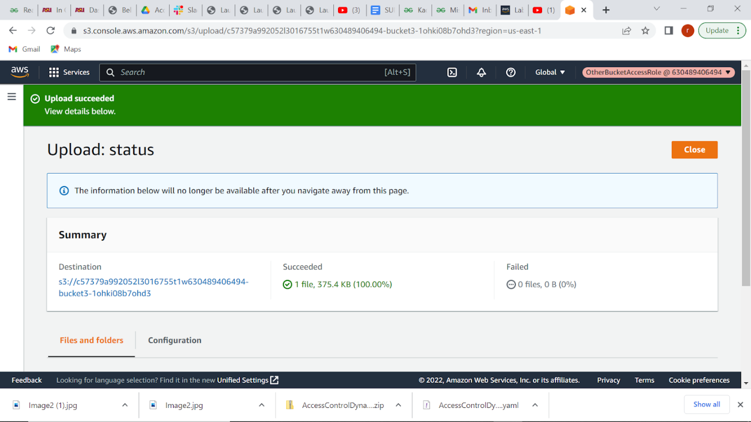

**Step 4 - Analyzing and extracting the data by creating lambda functions.**

## Product

## Final product details were upload in a website which was created using amazon s3 which contains details about safe payment methods and the percentage of people who are in risk for not using safe payment method and also contains details about no of people are interested in online gambling, amount of time they spend on it.

## Errors

1. Cleaning and extracting the column of data was difficult part and there were so many missing values but later we removed them using some data mining tasks